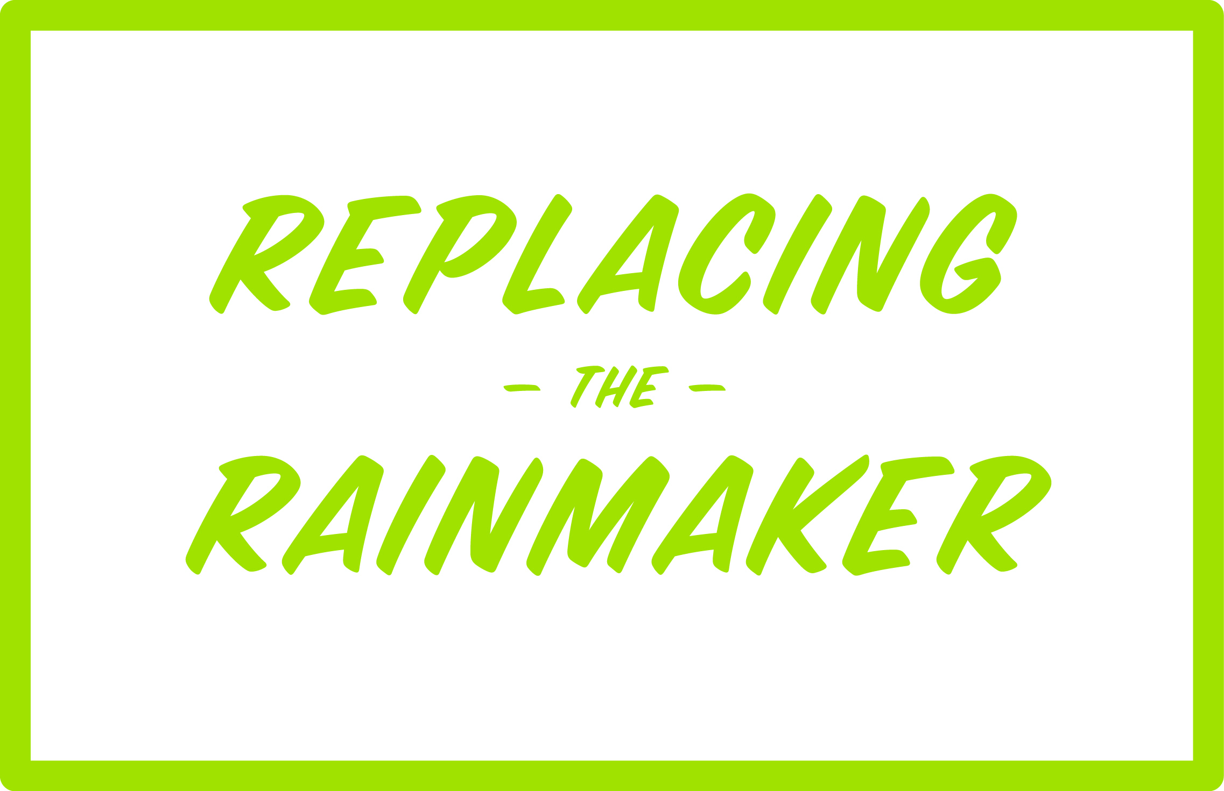 | Questions roadmap

This document is intended to give you a “head start” in creating your questions roadmap for calls and meetings with current and prospective clients. Pick and choose from the questions listed and add any tried-and-tested personal favorites that are specific to the client’s industry. Then format everything into a sequential questions roadmap.

Curiosity questions

- What led you to seek/take this meeting today?
- What are your expectations for today’s meeting? What do you hope to get out of it/learn from it/leave with today?

Vision questions

- What are the key strategic initiatives for your department/business/organization this year?
- What is the time frame for accomplishing these initiatives?
- How will accomplishing these initiatives affect the department/business/organization?
- What are you expected to contribute to the accomplishment of these initiatives?
- What role might an outside partner play in helping you accomplish these initiatives?

Current situation questions

- What is the primary mission of your department/business/organization?
- What are the critical success factors for you, your team and your organization?
- How is your organization measured and evaluated?
- What might be done to ensure or accelerate the accomplishment of your goals?
- What financial investment is required/available to accomplish these goals?
- What are the top three operational or business challenges you face on a daily/weekly basis?
- If you could change anything in the current environment, what would it be?
- Who/what puts the most demand on your department/business/organization? Explain.
- What grade would you give your current situation?

Impact questions

- What are your most pressing issues/challenges?
- What is the impact if the organization doesn’t solve these issues/challenges?
- How are these issue/challenges affecting sales? Profitability? Scheduling? Quality? Production?
- What do you think these issues/challenges are costing you?
- Let’s assume you decide not to address these issues/challenges immediately. What will that cost you this year?
- If you don’t fix the issues/challenges at hand, what is the potential impact on your business? Can you afford to take that risk?

Justification questions

- How does the organization justify this type of investment?
- How does the organization measure the success/failure of the investment after the fact?
- What contribution might a firm make to your justification process?

Competition questions

- Who is your current firm? What criteria did you base their selection on? Why are you considering leaving them?
- What alternatives is the organization considering?
- What are the key solution criteria that the successful firm must deliver?

Qualification questions

- What are the “must have” capabilities of the winning firm?
- What are the key evaluation criteria that will be used to select the winning firm?
- What lack of capability would automatically exclude a firm?
- How might the winning firm impact the overall goals of the company?

Decision-making questions

- What are the key steps in your decision-making process?
- What role do you personally play in the decision-making process?
- Who else is typically involved in these decisions and what role do they play?
- Who ultimately approves the investment and executes the agreement?
- At what point will you involve this individual?
- What is your timeframe for making a decision?

Our firm questions

- What do you know about our firm?
- What type of current client might be appropriate for you to call/visit?
- When would a presentation or demonstration of our capabilities be appropriate?
- Who should be invited to that presentation/demonstration meeting?
- What are the most valued characteristics of vendors that you consider as true partners?

Commitment questions

- What are the appropriate next steps for us?
- Are you ready to move forward with this?

