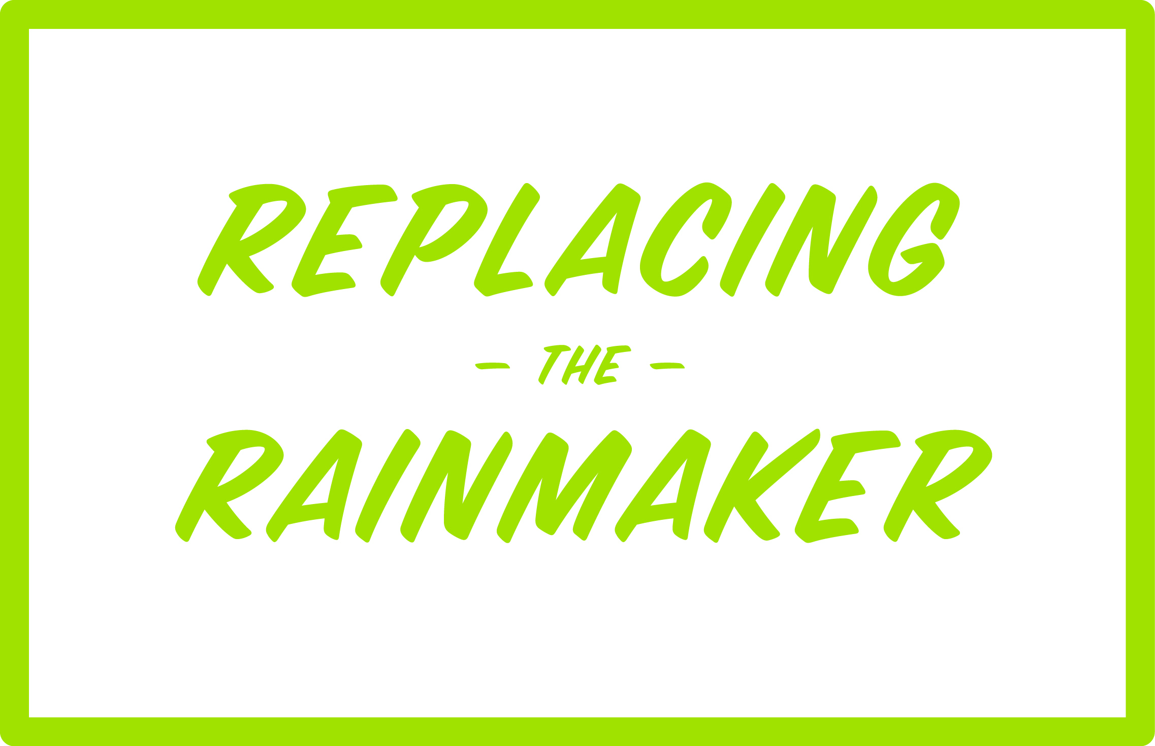 | Referral email

Ian is a business development consultant and author of the book “Replacing the Rainmaker.” He provides coaching and consulting services to accounting firms, helping them implement practices to ensure their long-term prosperity. His book is a practical guide to business development success for accountants, supplemented by online workshops and resources. You can learn more about his business at www.replacingtherainmaker.com. Outside of work, Ian’s passions include exercise, golf and travel. A native of England, he now lives in lives in Novato, California, with his wife and daughter. You can learn more about Ian at www.replacingtherainmaker.com/about.

