Wheel of influence map

Client name:

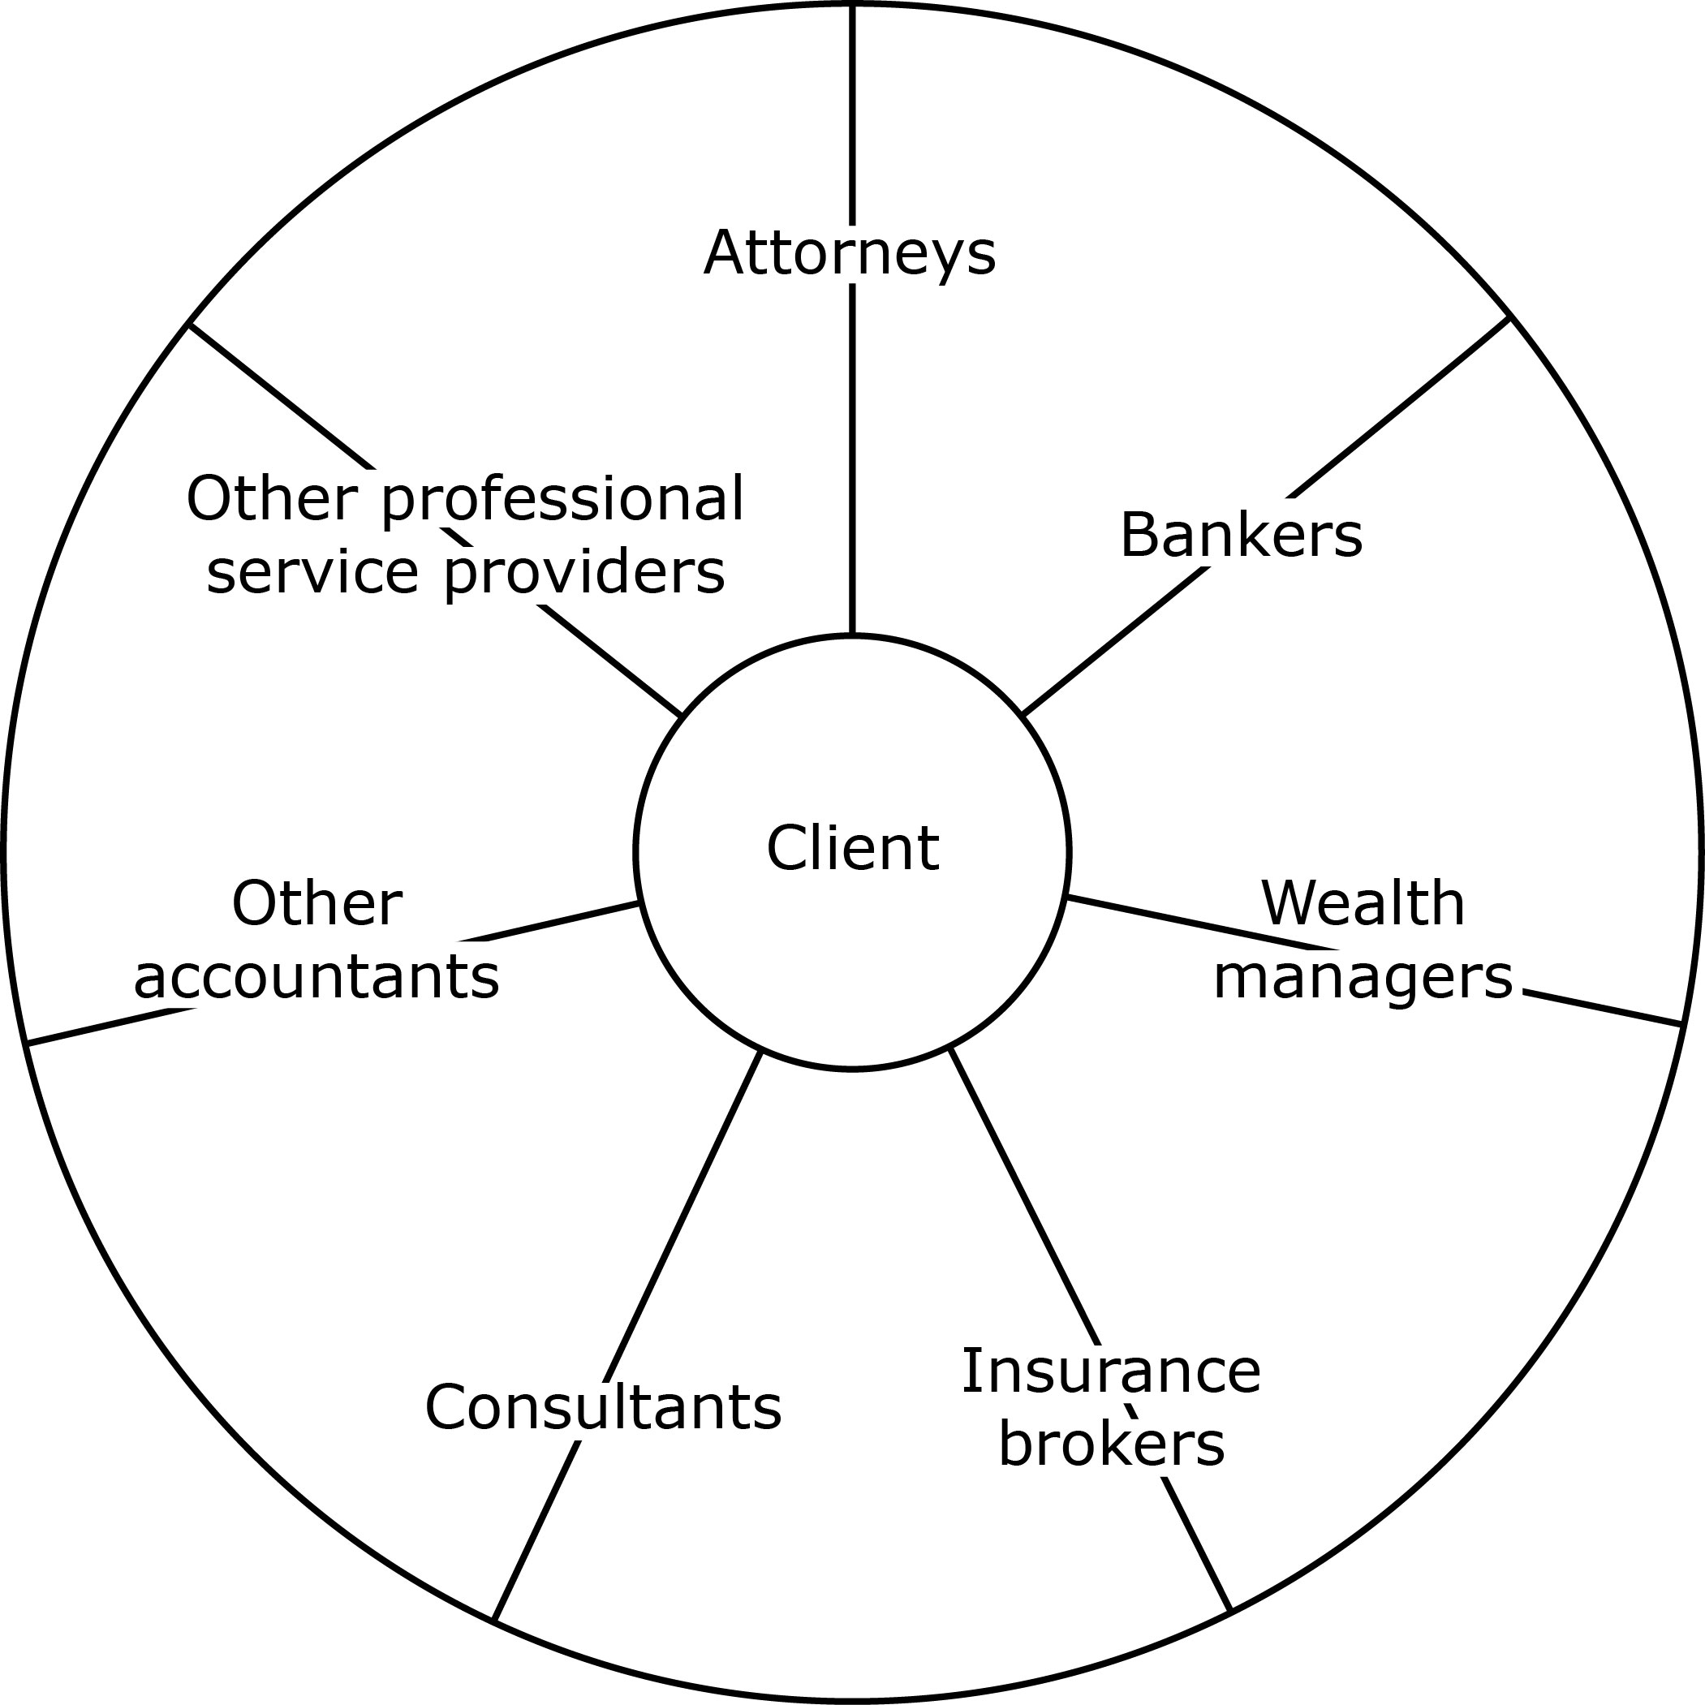

Note: A sample is included in the “Attorneys” table, below. Please type your information over this sample:

Attorneys

Type | Estate attorney | Name | John Phillips
Firm | Crossman, Jones & Phillips
Phone | XXX-123-4567 | Email | jphillips@cjpllp.com

Type | Business Attorney | Name | Ted Hagerman
Firm | Hagerman, Pearl & Christophe
Phone | XXX-456-7891 | Email | tedh@hpcllp.com

Type | Litigation Attorney | Name | Jonathan Pearl
Firm | Hagerman, Pearl & Christophe
Phone | XXX-456-7891 | Email | jonathanp@hpcllp.com

Bankers

Type |  | Name
Firm
Phone |  | Email

Type |  | Name
Firm
Phone |  | Email

Type |  | Name
Firm
Phone |  | Email

Wealth managers

Type |  | Name
Firm
Phone |  | Email

Type |  | Name
Firm
Phone |  | Email

Type |  | Name
Firm
Phone |  | Email

Insurance brokers

Type |  | Name
Firm
Phone |  | Email

Type |  | Name
Firm
Phone |  | Email

Type |  | Name
Firm
Phone |  | Email

Consultants

Type |  | Name
Firm
Phone |  | Email

Type |  | Name
Firm
Phone |  | Email

Type |  | Name
Firm
Phone |  | Email

Other accountants

Type |  | Name
Firm
Phone |  | Email

Type |  | Name
Firm
Phone |  | Email

Type |  | Name
Firm
Phone |  | Email

Other professional service providers

Type |  | Name
Firm
Phone |  | Email

Type |  | Name
Firm
Phone |  | Email

Type |  | Name
Firm
Phone |  | Email

